**Retail Store Assortment**

**CPFR | Retail Store Analysis Document**

This document offers information about how suppliers optimized their operation assortment.

**Document Audience:** Supply Chain Team

**Document Owner:** IT Consulting Company

**Document Author:** Sounak Dutta Chowdhury, Jr. Business Analyst

**Document Version:** v1.0

**Publication Date:** 05/08/2024

**Business Problem:**

In today's fast-paced retail environment, managing vendor and retail store assortment is a complex task.

Retailers face numerous challenges, including:

* **Overstocking and Understocking**: Inaccurate demand forecasting leads to stockouts, lost sales, and unnecessary inventory holding costs.
* **Inefficient Assortment Planning**: Manual processes and lack of data-driven insights result in suboptimal product offerings, leading to missed sales opportunities and decreased customer satisfaction.
* **Ineffective Product Placement**: Poor communication and lack of visibility into store performance, customer preferences led to stockouts or overstocking, increased management costs in instore.

**Purpose:**

The primary objective of this approach is to optimize retail store assortment, resulting in:

* **Improved Customer Satisfaction**: Enhanced product offerings and reduced stockouts lead to increased customer satisfaction and loyalty.
* **Increased Revenue**: Data-driven assortment planning and inventory optimization result in increased sales and revenue growth.
* **Product Accuracy:** Identification of product categories, colors, features, phone storage etc., breaking down products as per Breadth and Depth as per different locations is important for customer satisfaction.

**Scope:**

* Evaluate current retail store assortment practices.
* Identify challenges and inefficiencies in the existing system.
* Proper placement of products as per location and customer demands to improve customer satisfaction.
* Propose solutions to optimize inventory management and product assortment.
* Implement advanced analytics and technology solutions for better decision-making.

**Objectives:**

* Improve inventory turnover and reduce stockouts.
* Enhance customer satisfaction through better product availability.
* Increase sales and profitability by optimizing product assortment.
* Streamline supply chain operations for greater efficiency.

**Methodology:**

To address these challenges, a structured approach is necessary by leveraging data analytics, process optimization, and technology enablement. The methodology consists of the following phases:

1. **Data Collection and Analysis**: Gather historical sales data, vendor performance metrics, and customer feedback to identify trends, patterns, and areas for improvement.
2. **Assortment Planning and Optimization**: Utilize advanced analytics and machine learning algorithms to develop data-driven assortment plans, considering factors such as seasonality, customer preferences, and vendor performance.
3. **Supplier Management and Collaboration**: Implement a cloud-based supplier management platform to streamline communication, track performance, and enable real-time collaboration.
4. **Inventory Optimization and Replenishment**: Develop a dynamic inventory management system, leveraging predictive analytics and machine learning to optimize stock levels and minimize stockouts.

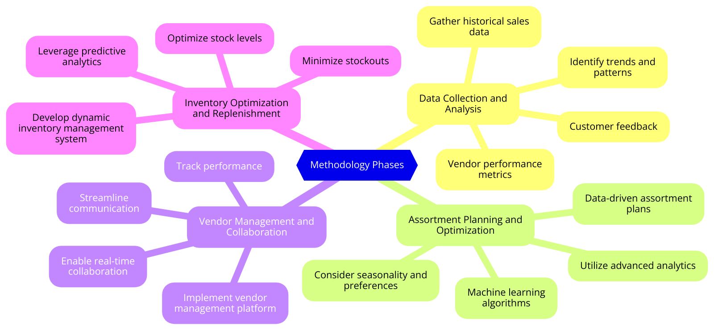

**Frameworks:**

1. **SCOR Model (Supply Chain Operations Reference)**:
   1. **Plan**: Develop a strategy for managing resources to meet customer demand.
   2. **Source**: Procure goods and services to meet planned or actual demand.
   3. **Make**: Transform products to a finished state to meet planned or actual demand.
   4. **Deliver**: Provide finished goods and services to meet planned or actual demand.
   5. **Return**: Return products, post-delivery customer support, and warranty management.
2. **ABC Analysis**:
   1. **A Items**: High-value items with low sales frequency.
   2. **B Items**: Moderate value and sales frequency.
   3. **C Items**: Low-value items with high sales frequency.
   4. **Use Case**: Classify inventory and prioritize management efforts based on item importance.
3. **Vendor Managed Inventory (VMI)**:
   1. **Description**: The supplier is responsible for maintaining the inventory levels at the retailer’s location.
   2. **Use Case**: Improved inventory turnover, reduced stockouts, and better supplier-retailer collaboration.
4. **Economic Order Quantity (EOQ)**:
   1. **Formula**: EOQ = √((2DS)/H), where D is demand, S is the order cost, and H is the holding cost.
   2. **Use Case**: Determine the optimal order quantity to minimize total inventory costs.
5. **Just-In-Time (JIT)**:
   1. **Description**: Inventory management strategy that aligns raw-material orders from suppliers directly with production schedules.
   2. **Use Case**: Reduce inventory holding costs and increase efficiency.

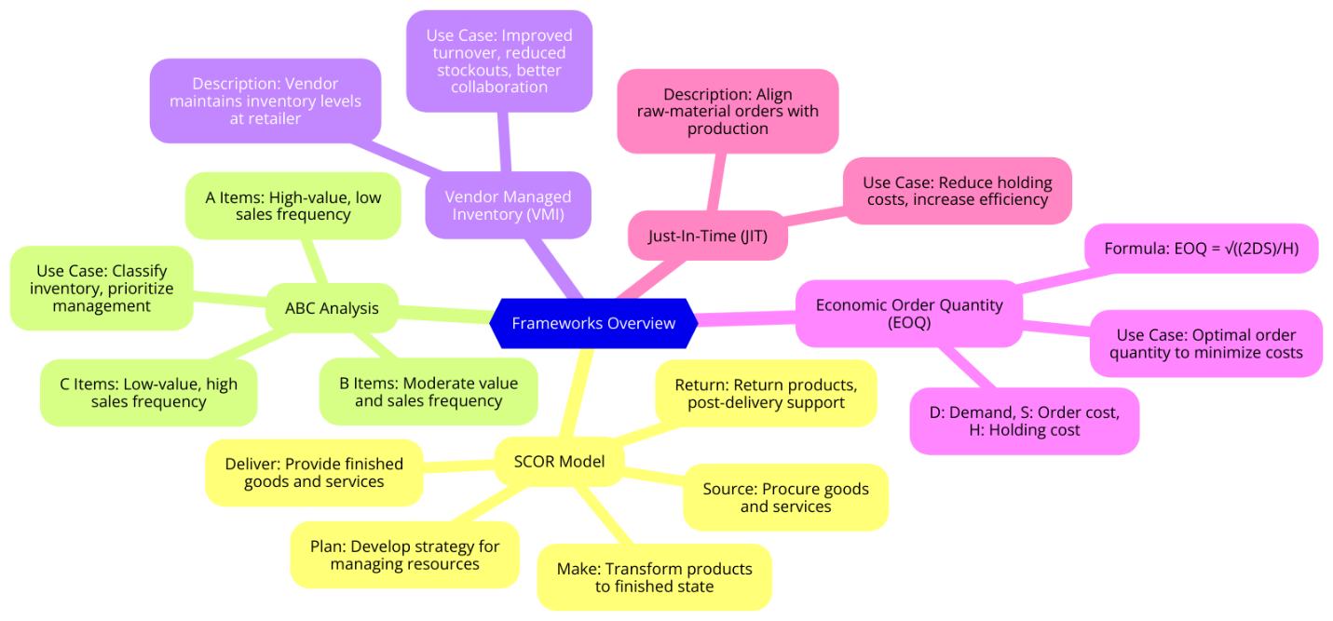

**Examples:**

1. **Walmart**:
   * **Problem**: Managing a vast product assortment across numerous stores.
   * **Solution**: Implementing advanced analytics and inventory management systems to optimize product assortment and stock levels.
   * **Framework Used**: SCOR Model and ABC Analysis.
2. **Amazon**:
   * **Problem**: Efficiently managing inventory for a wide range of products.
   * **Solution**: Utilizing machine learning algorithms for demand forecasting and inventory optimization.
   * **Framework Used**: EOQ and JIT.
3. **Target**:
   * **Problem**: Balancing inventory levels to meet customer demand without overstocking.
   * **Solution**: Employing VMI to enhance collaboration with suppliers and improve inventory management.
   * **Framework Used**: VMI and SCOR Model.

**Use Cases:**

1. **Retail Chain Optimizing Product Assortment**:
   * **Scenario**: A retail chain wants to optimize its product assortment to increase sales and reduce inventory costs.
   * **Framework**: ABC Analysis.
   * **Implementation**:
     + **Step 1**: Classify products into A, B, and C categories based on sales value.
     + **Step 2**: Prioritize items A for tighter inventory control and items B for regular monitoring.
     + **Step 3**: Use C items as filler stock to maintain store variety.
2. **Supplier Collaboration for Inventory Management**:
   * **Scenario**: A company struggles with stockouts and overstock situations.
   * **Framework**: Vendor Managed Inventory (VMI).
   * **Implementation**:
     + **Step 1**: Partner with key suppliers to manage inventory levels.
     + **Step 2**: Share real-time sales data with suppliers for better demand forecasting.
     + **Step 3**: Implement a system for automatic replenishment based on predefined stock levels.
3. **Demand Forecasting Using Advanced Analytics**:
   * **Scenario**: A retailer needs accurate demand forecasts to manage inventory effectively.
   * **Framework**: SCOR Model.
   * **Implementation**:
     + **Step 1**: Collect historical sales data and market trends.
     + **Step 2**: Use machine learning algorithms to predict future demand.
     + **Step 3**: Adjust inventory levels based on forecasted demand to prevent stockouts and overstocking.

**Assortment Affecting Factors:**

Retail store assortment is influenced by a variety of factors that retailers must consider meeting customer demands, optimize inventory, and maximize profitability.

Here are the key factors affecting retail store assortment:

1. **Customer Preferences and Demographics:**
   1. Understanding the target market's preferences, age, gender, income level, and lifestyle can help tailor the product assortment to meet their needs.
   2. Analyzing purchasing behavior and trends to stock popular and in-demand products.
2. **Market Trends and Seasonality:**
   1. Keeping up with current market trends and seasonal demands to adjust the assortment accordingly.
   2. Introducing new and trendy products to attract customers and stay competitive.
3. **Store Size and Layout:**
   1. The physical size of the store and the available shelf space dictate the variety and quantity of products that can be stocked.
   2. Efficient use of space to display products enhances the shopping experience.
4. **Suppliers Relationships and Supply Chain Management:**
   1. Building strong relationships with reliable suppliers to ensure a steady supply of quality products.
   2. Effective supply chain management to minimize stockouts and overstock situations.
5. **Pricing Strategy:**
   1. Setting competitive prices that align with the target market's expectations and purchasing power.
   2. Balancing premium and budget product offerings to cater to different customer segments.
6. **Brand Strategy:**
   1. Deciding on the mix of national brands, private labels, and local brands based on customer preferences and profitability.
   2. Promoting exclusive or high-margin products to enhance brand differentiation.
7. **Inventory Turnover and Shelf Life:**
   1. Monitoring inventory turnover rates to ensure fresh and relevant products are always available.
   2. Managing products with short shelf lives to reduce waste and markdowns.
8. **Competitor Actions:**
   1. Keeping an eye on competitors' assortments and strategies to make informed decisions about product selection.
   2. Differentiating the store's assortment to offer unique products and experiences.
9. **Technology and Data Analytics:**
   1. Utilizing data analytics to gain insights into customer behavior, sales patterns, and product performance.
   2. Implementing technology for inventory management, demand forecasting, and assortment planning.
10. **Location and Local Preferences:**
    1. Considering the store's geographic location and local customer preferences to tailor the product assortment.
    2. Stocking region-specific products that cater to local tastes and cultural preferences.
11. **Promotional Activities:**
    1. Planning assortments around promotional events, holidays, and sales campaigns to attract customers.
    2. Offering limited-time products or special deals to drive foot traffic and sales.
12. **Economic Factors:**
    1. Adapting the assortment in response to economic conditions, such as inflation, unemployment rates, and consumer confidence.
    2. Adjusting product offerings based on the economic environment to meet changing customer needs.

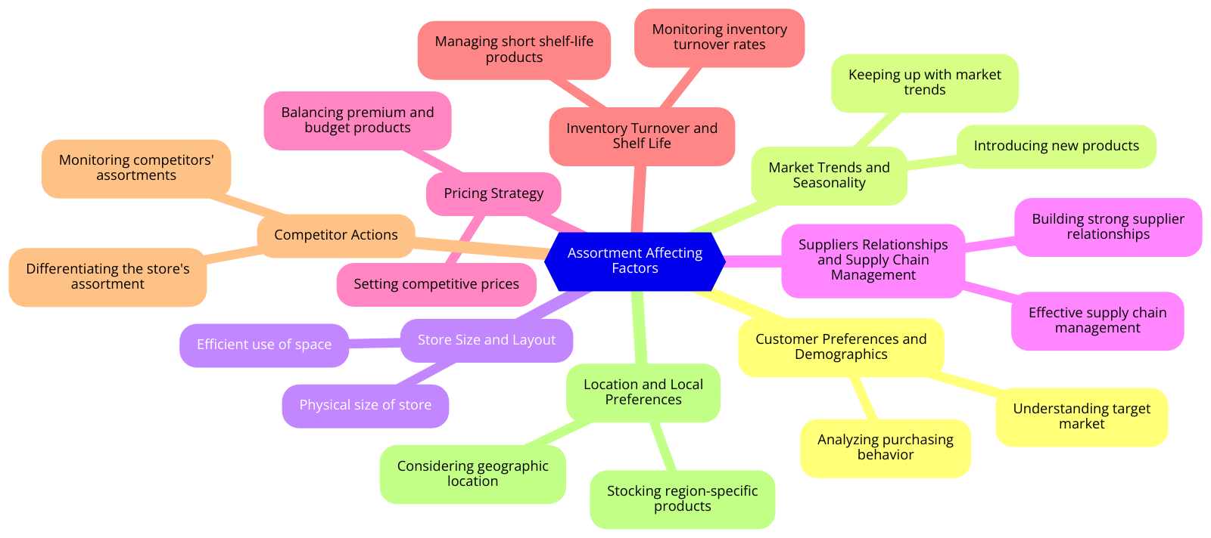

**Software Solution Providers:**

1. **SAP**:
   1. **Product**: SAP SCM (Supply Chain Management)
   2. **Clients**: Walmart, Procter & Gamble, Unilever
2. **Oracle**:
   1. **Product**: Oracle SCM Cloud
   2. **Clients**: Tesco, General Electric, Lenovo
3. **Blue Yonder (formerly JDA Software)**:
   1. **Product**: Blue Yonder Luminate Platform
   2. **Clients**: Starbucks, Carrefour, Coca-Cola
4. **Manhattan Associates**:
   1. **Product**: Manhattan Active Supply Chain
   2. **Clients**: Target, Adidas, Nordstrom

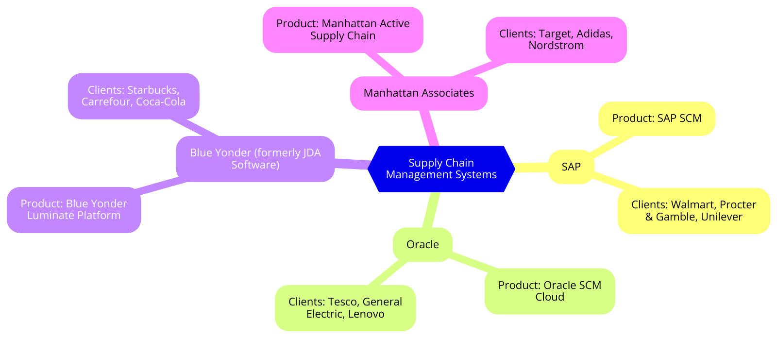

### **Examples and Use Cases:**

1. **Walmart with SAP SCM**:
2. **Problem**: Managing a vast and diverse product assortment across numerous stores.
3. **Solution**: Implementing SAP SCM to optimize inventory levels, improve demand forecasting, and streamline supply chain processes.
4. **Approach**:

* **Data Integration**: Consolidate sales data, supplier information, and market trends.
* **Advanced Analytics**: Use predictive analytics for accurate demand forecasting.
* **Inventory Optimization**: Implement automated replenishment processes based on real-time data.

1. **Improvement in Business Performance**:

* **Reduced Stockouts**: Ensured product availability, improving customer satisfaction.
* **Lower Holding Costs**: Optimized inventory levels, reducing excess stock.
* **Enhanced Supplier Collaboration**: Improved communication and efficiency with suppliers.

1. **Tesco with Oracle SCM Cloud**:
2. **Problem**: Balancing inventory levels to avoid stockouts and overstock situations.
3. **Solution**: Using Oracle SCM Cloud for real-time visibility and advanced inventory management.
4. **Approach**:

* **Cloud Integration**: Integrate all supply chain data into a single cloud-based platform.
* **Demand Sensing**: Use machine learning algorithms to sense and respond to changes in demand.
* **Vendor Management**: Improve collaboration with vendors through shared data and automated processes.

1. **Improvement in Business Performance**:

* **Increased Sales**: Better inventory management led to fewer stockouts.
* **Reduced Costs**: Lowered holding costs by reducing overstock.
* **Improved Efficiency**: Streamlined supply chain operations through automation.

1. **Starbucks with Blue Yonder Luminate Platform**:
2. **Problem**: Ensuring consistent product availability across global locations.
3. **Solution**: Leveraging Blue Yonder’s Luminate Platform for demand forecasting and inventory optimization.
4. **Approach**:

* **Predictive Analytics**: Use advanced algorithms to forecast demand accurately.
* **Inventory Replenishment**: Implement JIT inventory practices to minimize waste.
* **Supply Chain Visibility**: Enhance visibility across the supply chain to monitor and adjust inventory in real time.

1. **Improvement in Business Performance**:

* **Optimized Inventory**: Reduced waste and improved product availability.
* **Enhanced Customer Experience**: Consistent availability of products improved customer satisfaction.
* **Cost Savings**: Reduced unnecessary inventory holding costs.

1. **Target with Manhattan Active Supply Chain**:
2. **Problem**: Managing inventory across numerous retail locations with varying demand patterns.
3. **Solution**: Implementing Manhattan Active Supply Chain to optimize store-level inventory and improve vendor relationships.
4. **Approach**:

* **Unified Platform**: Consolidate all inventory data into a single, integrated system.
* **Vendor Collaboration**: Utilize VMI to allow vendors to manage inventory levels.
* **Inventory Planning**: Use ABC analysis to prioritize inventory management efforts.

1. **Improvement in Business Performance**:

* **Reduced Stockouts**: Ensured critical items were always in stock.
* **Efficient Inventory Turnover**: Improved turnover rates by aligning inventory with demand.
* **Better Vendor Relations**: Enhanced collaboration with vendors led to more reliable supply chains.

**Solution Overview:**

To address these challenges, a list of comprehensive solutions is necessary that leverages data analytics, process optimization, and technology enablement. The solution consists of the following components:

1. **Data Collection and Analysis**: Gather historical sales data, vendor performance metrics, and customer feedback to identify trends, patterns, and areas for improvement.
2. **Assortment Planning and Optimization**: Utilize advanced analytics and machine learning algorithms to develop data-driven assortment plans, considering factors such as seasonality, customer preferences, and vendor performance.
3. **Supplier Management and Collaboration**: Implement a supplier management platform to streamline communication, track performance, and enable real-time collaboration.
4. **Inventory Optimization and Replenishment**: Develop a dynamic inventory management system, leveraging predictive analytics and machine learning to optimize stock levels and minimize stockouts.

* **Data Collection and Analysis**

To develop a comprehensive understanding of the current state of vendor and retail store assortment, it is essential to collect and analyze relevant data. This includes:

1. **Historical Sales Data**: Collect sales data from various sources, including point-of-sale systems, e-commerce platforms, and customer relationship management (CRM) systems.
2. **Supplier Performance Metrics**: Gather data on supplier performance, including lead times, fill rates, and quality ratings.
3. **Customer Feedback**: Collect customer feedback through surveys, social media, and customer reviews to understand their preferences and expectations.

**Example**

A leading retailer, Walmart, collected historical sales data from its point-of-sale systems and e-commerce platform. The data revealed that sales of outdoor furniture increased by 20% during the summer months. This insight informed the development of a data-driven assortment plan, which included a wider selection of outdoor furniture during the summer season.

* **Assortment Planning and Optimization**

To develop an optimized assortment plan, it is essential to leverage advanced analytics and machine learning algorithms. This includes:

1. **Data-Driven Assortment Planning**: Utilize machine learning algorithms to analyze historical sales data, vendor performance metrics, and customer feedback to develop a data-driven assortment plan.
2. **Seasonality and Trend Analysis**: Analyze seasonal trends and patterns to inform the assortment plan.
3. **Vendor Performance Analysis**: Evaluate vendor performance to ensure that the assortment plan is aligned with vendor capabilities.

**Example**

A leading retailer, Target, utilized machine learning algorithms to develop a data-driven assortment plan. The plan revealed that customers preferred a wider selection of organic products. Target adjusted its assortment plan to include a greater variety of organic products, resulting in a 15% increase in sales.

* **Supplier Management and Collaboration**

To streamline communication and collaboration with vendors, it is essential to implement a vendor management platform. This includes:

1. **Vendor Management Platform**: Implement a platform that enables real-time communication and collaboration with suppliers.
2. **Performance Tracking**: Track vendor performance metrics, including lead times, fill rates, and quality ratings.
3. **Collaborative Planning**: Collaborate with vendors to develop a joint business plan, including sales forecasts, inventory levels, and logistics.

**Example**

A leading retailer, Home Depot, implemented a supplier management platform to streamline communication and collaboration with its suppliers. The platform enabled real-time tracking of performance metrics, resulting in a 20% reduction in stockouts.

* **Inventory Optimization and Replenishment**

To optimize inventory levels and minimize stockouts, it is essential to develop a dynamic inventory management system. This includes:

1. **Predictive Analytics**: Utilize predictive analytics to forecast demand and optimize inventory levels.
2. **Machine Learning**: Leverage machine learning algorithms to analyze historical sales data and optimize inventory replenishment.
3. **Real-Time Monitoring**: Monitor inventory levels in real-time to ensure that stock levels are optimized.

**Example**

A leading retailer, Walmart, developed a dynamic inventory management system that utilized predictive analytics and machine learning algorithms to optimize inventory levels. The system resulted in a 15% decrease in inventory holding costs.

**Advantages and Disadvantages of Software Solutions:**

* **Advantages**:
  1. **Improved Forecast Accuracy:** Advanced analytics provide more accurate demand forecasts.
  2. **Real-Time Data Integration:** Seamless data integration enables real-time decision-making.
  3. **Enhanced Vendor Management:** Better coordination and performance monitoring of vendors.
  4. **Optimized Inventory Levels:** Reduced holding costs and minimized stockouts.
  5. **Scalable Solutions:** Solutions can scale with business growth and complexity.
* **Disadvantages**:
  1. **High Implementation Costs:** Significant investment required for initial setup and customization.
  2. **Complexity:** Solutions can be complex to deploy and require extensive training.
  3. **Integration Challenges:** Potential difficulties in integrating with existing legacy systems.
  4. **Subscription Costs:** Ongoing subscription fees can be high for comprehensive solutions.
  5. **Limited Customization:** Some solutions may offer limited customization options, impacting flexibility.

**Results:**

A client engagement with a leading retailer demonstrates the effectiveness of this approach:

1. **10% Increase in Sales**: Data-driven assortment planning and inventory optimization resulted in a 10% increase in sales within the first six months.
2. **20% Reduction in Stockouts**: Improved vendor management and inventory optimization led to a 20% reduction in stockouts, resulting in increased customer satisfaction.
3. **15% Decrease in Inventory Holding Costs**: Streamlined inventory management and optimized stock levels resulted in a 15% decrease in inventory holding costs.

### **Business Performance:**

1. **Improved Demand Forecasting**: Advanced analytics and machine learning improve the accuracy of demand forecasts, leading to better inventory planning and reduced stockouts.
2. **Enhanced Inventory Management**: By optimizing inventory levels, companies reduce holding costs and avoid overstock situations, leading to cost savings.
3. **Better Supplier Relationships**: Enhanced collaboration with suppliers through shared data and automated processes leads to more reliable supply chains and better product availability.
4. **Increased Sales and Customer Satisfaction**: Ensuring product availability and meeting customer demand improves overall sales and customer satisfaction.
5. **Cost Efficiency**: Implementing efficient inventory management practices and reducing excess inventory leads to significant cost savings.

**Business Recommendations:**

Based on the results and insights the recommendations are following:

1. **Implement a Data-Driven Assortment Planning Process**: Leverage advanced analytics and machine learning algorithms to develop optimized assortment plans.
2. **Invest in a Supplier Management Platform**: Streamline communication and collaboration with suppliers to improve performance and reduce costs.
3. **Develop a Dynamic Inventory Management System**: Utilize predictive analytics and machine learning to optimize stock levels and minimize stockouts.